Assignment 3 - Car Number Plate Detection Pipeline

# Purpose:

Through this assignment, we intend to design an end to end pipeline for detecting car number plates from car number plates images and display an inference obtained to the user on Flask application.

# Dataset:

Dataset will be images uploaded by the users on the Flask application. User can upload any type of image.

Users will be restricted to upload only JPEG and PNG image formats.

# Architecture Diagram:

Below is the architecture diagram for this assignment.

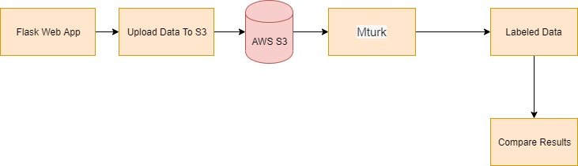

# Processes Involved

## Data Ingestion:

Images uploaded by users on the Flask web application will be stored in AWS S3 bucket ‘info7374-image-detection’ under Raw folder.

On the web interface, when the user selects a file from his computer to upload the image and clicks on Upload button, then the file is stored in AWS S3 bucket. Users can upload images only in certain formats like PNG and JPEG formats.

## Data Processing:

Images uploaded in S3 bucket are then sent to Amazon Mechanical Turk Service. Amazon Mechanical Turk service can be used to create different tasks and these tasks can be completed by workers or project team depending upon the use case. In this assignment we have used to Amazon Mechanical Turk Service for 2 purposes listed below:

### **Task 1:** Whether it is a car number plate image?

Image uploaded in S3 bucket will be displayed and the user will be asked whether it is a car number plate image or not.

Based on the response received from the user for Task 1, another Task will be displayed for the user.

### **Task 2 :** Write the license number plate text displayed on the image.

Here, the user is supposed to mention same text as displayed on the image.

This is used for validation purposes.

## Data Inference:

In this stage, the name of the file and bucket name will be passed as parameters to Amazon Rekognition API which has DetectText method. DetectText method will detect text in an image and will display the result.

End users will be able to see text displayed on the image when the user clicks on Infer button.

Inference is evaluated and user is shown results from Mechanical Turk task and results achieved from the Amazon Rekognition API on the Flask Web application.

# References:

<https://docs.aws.amazon.com/rekognition/latest/dg/API_Reference.html>

<https://docs.aws.amazon.com/sagemaker/latest/dg/object-detection.html>

<https://www.mturk.com/>